New Market District VFC
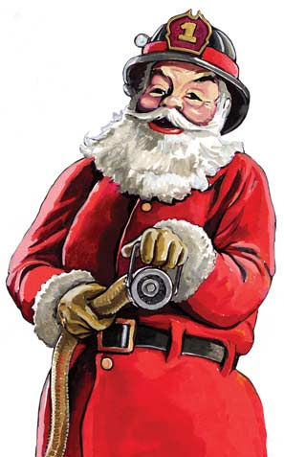
2017 Santa Run Schedule
Merry Christmas & Happy Holidays to all! The New Market District Volunteer Fire Company will conduct its annual “Santa Run” beginning Monday December 4th, 2017. All “Santa Runs” will begin at approximately 6:30pm & go no later than 8:30pm each night. Please refer to the following schedule to see when Santa will be in your neighborhood:
- Monday December 4th – Mussetter Road communities (including Players Walk) and the housing development off of and around Jordan Blvd.
- Tuesday December 5th – Lake Linganore Meadows & Westwinds communities
- Wednesday December 6th – Coldstream & Woodridge communities
- Thursday December 7th – Pinehurst community
- Monday December 11th – New Market West & Summerfield communities as well as Main St.
- Tuesday December 12th – Orchards, Brinkley Manor & Royal Oak communities
- Thursday December 14th – Catoctin View, Meadow at New Market & Woodspring communities
- Tuesday December 19th – Windsor Knolls community
Please keep in mind we are a full service Fire & EMS Department. Santa and his reindeer (our apparatus) may be summoned to calls for service before or during our trip through your community. You can follow us on Twitter (@NewMarketVFC) for up to the minute call statuses. We will make all attempts to minimize the interruptions & reschedule our preplanned Santa Runs as necessary and able, however, serving the citizens of our community who are in need is our #1 priority!
December 15th and December 18th will be used as dates for additional coverage and or make up visits should Santa and his reindeer be help up by inclement weather or calls for service. Stay tuned to our company website, www.nmvfc15.org, Facebook Account (New Market Volunteer Fire Department 1525) or other social media accounts for updates and schedule changes.
In an effort to maximize our time and coverage, we will most likely remain on the larger streets and courts. We encourage residents who live on more narrow courts and streets to gather as a group at the end of the intersecting roadway as you begin to hear the sirens and horns. This will alleviate us having to negotiate turning around large apparatus in tight areas, which is a dangerous practice in low light conditions. As always, thank you for your continued support of the New Market District Volunteer Fire Company!

